|  |  |  |  |  |  |  |  |  |  |  |  |  |  |  |  |  |  |
| --- | --- | --- | --- | --- | --- | --- | --- | --- | --- | --- | --- | --- | --- | --- | --- | --- | --- |
|  |  |  |  |  |  |  |  |  |  |  |  |  |  |  |  |  |  |
|  |  |  |  |  |  |  |  |  |  |  |  |  |  |  |  |  |  |
|  |  |  |  |  |  |  |  |  |  |  |  |  |  |  |  |  |  |

|  |  |  |  |  |  |  |  |  |  |  |  |  |  |  |  |  |  |
| --- | --- | --- | --- | --- | --- | --- | --- | --- | --- | --- | --- | --- | --- | --- | --- | --- | --- |
| J | O | H | N |  | S | M | I | T | H | , | J | R | . |  |  |  |  |

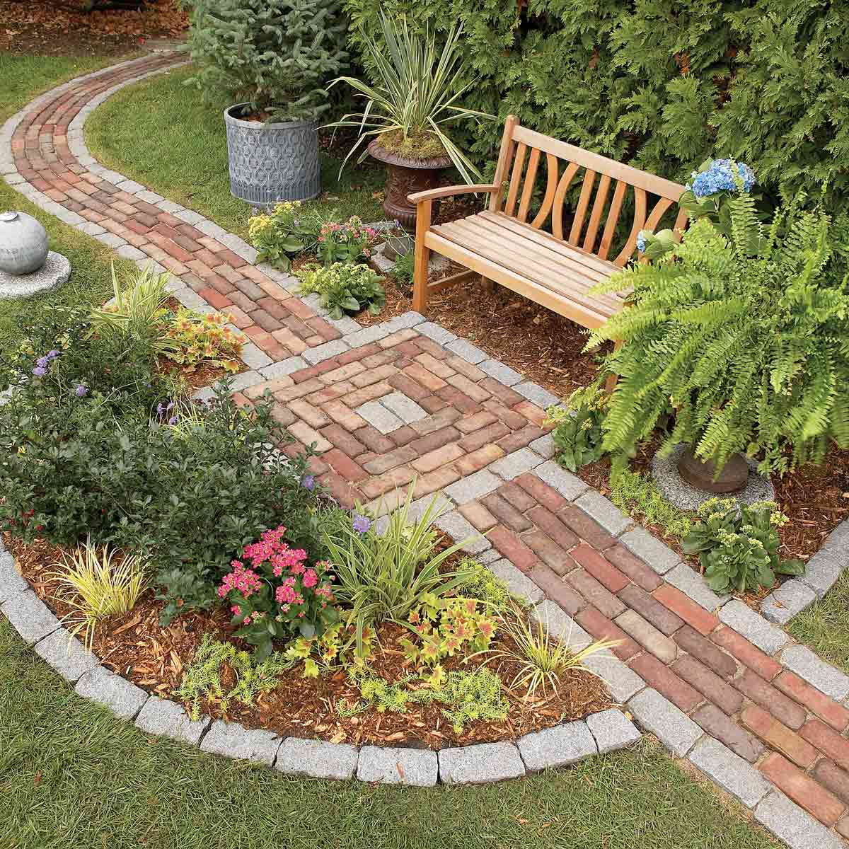

**PLEASE FILL IN THE BOXES BELOW WITH ONE CHARACTER PER BOX, INCLUDING SPACES AND PUNCTUATION**

Purchaser contact info:

Name__________________ Email____________________ Phone #:____________________

LINE 3

LINE 2

LINE 1

EXAMPLE:

**Limit: Up to 3 lines, 18 characters per line, including spaces and punctuation**

We invite you to purchase a brick for our Peaceful Walkway at our Center. These bricks can mark a special occasion, honor a special person or be in memory of a loved one.

Each brick costs $100 and will be inscribed according to your request, which must fit into three lines with 18 characters per line including spaces and punctuation. They will be placed on a path surrounding our garden.

Please make checks payable to:

EBC Center

PO Box 9476

Warwick, RI 02889

Business: 401.738.9700

Fax: 401.738.1713

www.ebccenter.org

info@ebcceenter.org